
MASENO UNIVERSITY
SCHOOL OF COMPUTING AND INFORMATICS
DEPARTMENT OF INFORMATION TECHNOLOGY
BACHELOR OF SCIENCE IN INFORMATION TECHNOLOGY
TRAVEL AND TOURISM PORTAL
CODE: CIT 409
ADM: CIT/00187/022
NAME: SAMUEL KAMANDE NJUGUNA
SUPERVISOR: ISAAC OWINO
REPORT SUBMITTED TO THE SCHOOL OF COMPUTING AND INFORMATICS, IN PARTIAL FULFILLMENT OF THE REQUIREMENTS FOR THE AWARD OF BACHELOR OF SCIENCE DEGREE IN INFORMATION TECHNOLOGY.
SEPTEMBER – JANUARY 2026

DECLARATION
I, Samuel Kamande Njuguna, registration number CIT/00187/022, hereby declare that this project proposal titled “Travel & Tourism Portal” is my original work and has not been presented for the award of any certificate, diploma, or degree in any other institution. All sources of information used have been duly acknowledged through references.
Signed: ___________________________
Date: _____________________________

Supervisor
Name ___________________________
Signature ________________________
Date ___________________________ _

ABSTRACT
Tourism is a key contributor to Kenya’s economic growth, yet travellers continue to face challenges in accessing reliable, centralized, and up-to-date tourism information. Information on attractions, accommodation, events, restaurants, and transport routes is often scattered across multiple platforms, making travel planning time-consuming and inefficient. This project proposes the design and development of a web-based Travel & Tourism Portal that integrates essential tourism services into a single, user-friendly platform. The system will provide verified information on tourist attractions, hotels, restaurants, events, routes, booking options, reviews, and simulated payment services. The study adopts a descriptive research design and uses the Incremental Development Model to guide system development. The proposed system aims to enhance travel planning efficiency, promote local tourism businesses, and improve the overall travel experience in Kenya.

ACKNOWLEDGEMENT
I would like to express my sincere gratitude to my lecturer and project supervisor for their guidance, support, and constructive feedback throughout the development of this project proposal. I also appreciate my classmates and friends for their encouragement and ideas. Special thanks go to my family for their continued support and motivation during my studies. Above all, I thank God for the strength, wisdom, and perseverance to complete this work.

Table of Contents
LIST OF ABBREVIATIONS 6
DEFINITION OF TERMS 7
LIST OF FIGURES 8
CHAPTER ONE: INTRODUCTION 9
1.1 Background 9
1.2 Problem Statement 9
1.3 Overall Objective 10
1.4 Specific Objectives 10
1.5 Scope and Limitations 10
1.6 Significance of the Project 11
CHAPTER TWO: LITERATURE REVIEW 11
2.1 Introduction 11
2.2 Overview of Tourism Information Systems 11
2.3 Digital Travel Platforms Worldwide 12
2.4 Tourism Technology in Africa 12
2.5 Travel and Tourism Systems in Kenya 12
2.6 Review of Related Works 13
2.7 Identified Gaps in Existing Literature and Systems 13
Addressing These Gaps 14
CHAPTER THREE: METHODOLOGY 14
3.1 Introduction 14
3.2 Research Design 14
3.3 System Development Methodology 14
3.4 Data Collection Methods 15
3.5 System Requirements 15
3.5.1 Functional Requirements 15
3.5.2 Non-Functional Requirements 15
3.6 System Design 16
3.6.1 System Architecture 16
3.6.2 Database Design 16
3.7 Tools and Technologies 17
3.8 System Development Environment 18
CHAPTER FOUR: SOLUTION ANALYSIS & SPECIFICATION 19
4.1 Introduction 19
4.2 Requirements Determination 19
4.2.1 Functional Requirements 19
4.2.2 Non-Functional Requirements 19
4.3 Requirements Analysis 19
4.3.1 Data Flow Diagrams (DFDs) 19
4.3.3 Solution Modelling Artefacts 20
4.4 Solution Specifications 20
4.5 Requirements Specifications (Tools & Justification) 21
4.6 Student’s Presentation (Originality, Ownership, and Relevance) 21

LIST OF ABBREVIATIONS
- API – Application Programming Interface
- CSS – Cascading Style Sheets
- DFD – Data Flow Diagram
- ERD – Entity Relationship Diagram
- HTML – HyperText Markup Language
- ICT – Information and Communication Technology
- KTB – Kenya Tourism Board
- KWS – Kenya Wildlife Service
- TIS – Tourism Information System

DEFINITION OF TERMS
- Attraction: A place of interest that draws tourists, such as parks, cultural sites, or landmarks.
- Booking: The process of reserving accommodation, events, or tourism services through the system.
- Entity Relationship Diagram (ERD): A visual representation showing database entities and their relationships.
- Incremental Development Model: A system development approach where the system is built in small, functional stages.
- Portal: A web-based platform that provides access to multiple related services and information from a single point.
- Route: A mapped path showing directions between locations for travel and navigation.
- Tourism Information System (TIS): A digital system that supports tourism-related information access, planning, and management.

LIST OF FIGURES
Figure 3.1: System Architecture Diagram
Figure 3.2: Entity Relationship Diagram (ERD)
Figure 4.1: Use Case Diagram

CHAPTER ONE: INTRODUCTION

1.1 Background
Tourism is a fast-growing sector worldwide and a key contributor to economic growth in many countries, including Kenya. In fact, tourism not only boosts GDP but also creates employment opportunities, promotes cultural exchange, and stimulates infrastructural development. With Kenya’s diverse attractions, ranging from wildlife safaris, coastal beaches, mountain trekking, cultural heritage sites, and urban experiences, the country continues to attract both local and international travellers.
With the increase in domestic and international travel, there is a rising demand for easy, reliable, and timely access to information on tourist attractions, accommodation facilities, restaurants, cultural events, and transport routes. Travellers increasingly prefer digital solutions that can simplify trip planning, reduce uncertainties, and provide verified recommendations.
However, most travellers still struggle to find consolidated and trustworthy information in one place. Many rely on scattered sources such as blogs, social media posts, word of mouth, and outdated websites. These sources often lack comprehensive coverage, are not regularly updated, and may not provide verified details on pricing, availability, and location. Such challenges limit the travel experience, discourage exploration of hidden destinations, and affect tourism growth.
Digital platforms such as websites and mobile apps are increasingly bridging this gap by providing centralized, user-friendly, and accessible travel guides. A Travel & Tourism Guide Website provides travellers with a one-stop solution for discovering attractions, booking hotels, exploring routes, and learning about local events. By integrating maps, reviews, secure payment options, and booking systems, such platforms enhance convenience, promote local tourism, and strengthen trust between travellers and service providers.
This project seeks to design and develop such a platform tailored to meet user needs while also promoting local tourism in Kenya. The system will combine attraction details, accommodation booking, event listings, transport routes, and secure payment options into a single, interactive website.

1.2 Problem Statement
Despite Kenya’s vibrant tourism sector, travellers continue to face significant challenges when planning and managing their trips. Information on destinations, accommodation, events, and transport is often scattered across multiple platforms, ranging from blogs and social media to outdated or unverified websites. This creates several issues, such as:
- Inaccurate or outdated information on pricing, location, and availability of services.
- Booking difficulties caused by the absence of centralized reservation systems.
- Misinformation and fraud, especially when relying on unverified sources.
- Missed opportunities to explore hidden or less-advertised attractions due to lack of visibility.
- Time-consuming searches across multiple platforms, reducing the convenience of travel planning.
The absence of a centralized, reliable, and user-friendly platform that integrates tourist attractions, routes, hotels, restaurants, reviews, and booking/payment options presents a gap that must be addressed.
This project aims to solve this problem by developing a comprehensive Travel & Tourism Guide Website that consolidates verified and up-to-date information, provides booking and payment functionalities, and enhances the overall user experience. The system will not only benefit travellers but also support local businesses by improving their visibility and accessibility to potential clients.

1.3 Overall Objective
To design and develop a responsive web-based Travel & Tourism Guide system that consolidates attractions, routes, accommodations, and booking options to improve accessibility and enhance travel experiences.

1.4 Specific Objectives
- To design a user-friendly website that highlights key tourist attractions, hotels, restaurants, and events.
- To integrate booking features for hotels, restaurants, and events; and their respective reviews
- To implement a secure payment system.
- To integrate an interactive map for routes and nearby attractions.

1.5 Scope and Limitations
Scope:
The project will focus on developing a web-based platform accessible via desktops and mobile devices. It will provide travellers with access to attractions, accommodations, restaurants, events, routes, booking options, and payments. The system will also allow users to rate, review, and save preferences.
Limitations:
- The system will use dummy/test data during development (no live hotel/airline integration initially).
- Payment will be simulated for demonstration purposes.
- Real-time booking confirmations may not be fully functional until integrated with external APIs.
- The system will focus on Kenya as the initial case study before scaling regionally or globally.

1.6 Significance of the Project
This project will significantly improve how travellers access tourism information by providing a centralized and reliable platform. It will:
- Enhance convenience and efficiency in trip planning.
- Promote local attractions and businesses by increasing visibility.
- Provide a learning opportunity for the developer to apply web development, database management, and system integration skills.
- Serve as a foundation for future enhancements such as mobile app integration and real-time bookings.

CHAPTER TWO: LITERATURE REVIEW

2.1 Introduction
This chapter reviews existing literature related to tourism information systems, digital travel platforms, and the use of technology in tourism across global, African, and Kenyan contexts. It also examines related studies and highlights gaps that the proposed Travel and Tourism Portal seek to address (Smith, 2018; Karanja, 2020).

2.2 Overview of Tourism Information Systems
Technology has significantly transformed how tourists access information, plan trips, and interact with destinations. Tourism Information Systems (TIS) bring together web platforms, mobile applications, geolocation tools, and multimedia content to support tourists throughout the entire travel process—from destination discovery and planning to booking and post-trip engagement (Smith, 2018).
Modern TIS focus on creating solutions that are easy to use, visually appealing, and responsive to individual user needs. Features such as personalized recommendations, real-time updates, and digital mapping have become essential in enhancing tourist satisfaction and improving service delivery (Karanja, 2020). These principles form the foundation for developing efficient, user-centred tourism platforms.

2.3 Digital Travel Platforms Worldwide
Globally, platforms like TripAdvisor, Booking.com, Expedia, and Airbnb have reshaped the travel industry by offering comprehensive travel resources. These platforms usually include features such as:
- User-generated reviews and ratings
- Real-time availability and booking systems
- Secure online payments
- Location-based suggestions and smart recommendations
Studies show that peer-generated reviews significantly influence destination choices, as travellers trust feedback from other users more than traditional marketing messages (Kim & Park, 2019). However, despite their global dominance, many of these platforms provide limited coverage or shallow insights for African destinations. Mwangi (2021) notes that global travel platforms often overlook localized cultural experiences and may not capture county-level tourism data. This gap highlights the need for region-specific digital solutions.

2.4 Tourism Technology in Africa
Across Africa, countries are increasingly adopting digital tools to market their destinations and improve access to tourism information. South Africa, Morocco, and Rwanda, for example, have developed national tourism portals that showcase attractions, issue online permits, provide travel advisories, and promote cultural events (Adebayo, 2020).
Despite this progress, several challenges remain. Many African tourism systems struggle with inconsistent data updates, fragmented information sources, and limited digital coordination among tourism stakeholders (Ncube, 2022). These issues reduce the reliability of available information and make it difficult for travellers to plan effectively. As a result, African tourism often loses competitive advantage in the global digital marketplace.

2.5 Travel and Tourism Systems in Kenya
Kenya’s tourism industry heavily relies on online resources and digital marketing. Platforms managed by the Kenya Tourism Board (KTB) and private sector players showcase destinations, wildlife, parks, hotels, travel packages, and cultural attractions (Mutiso, 2020). Common platforms include:
- Magical Kenya, the official tourism website
- Websites belonging to local tour operators
- Hotel booking platforms
- Travel blogs and social media travel pages
While these sources provide valuable information, research shows that many lack a unified and user-friendly experience. Omondi (2022) notes that existing Kenyan platforms often focus on specific aspects—such as attractions or accommodation—without combining transport routes, itineraries, reviews, and interactive features in one place. This fragmented approach reduces their usefulness for both local and international tourists seeking a comprehensive travel planning tool.

2.6 Review of Related Works
Several studies have explored the development of tourism information systems across Africa:
- Nigeria: Adebayo (2020) built a web-based tourism portal providing destination listings, maps, and hotel information. The platform improved accessibility but lacked interactive trip planning tools.
- South Africa: Nkosi (2019) developed a mobile travel guide with geolocation support. However, the system had limited content depth and did not include booking integrations.
- Kenya Wildlife Service (KWS): Karanja (2021) reviewed the KWS digital platform, noting strengths in wildlife information but highlighting gaps in accommodation reviews, real-time updates, and customization.
- East African Community (EAC): Mwangi (2021) examined regional tourism digital systems and found them inconsistent, fragmented, and lacking standardized data.
Overall, existing studies demonstrate growth in digital tourism initiatives but emphasize the need for more comprehensive, integrated, and user-oriented platforms tailored to specific national contexts (Smith, 2018; Omondi, 2022).

2.7 Identified Gaps in Existing Literature and Systems
Based on the reviewed studies and platforms, several key gaps remain unaddressed:
Gap 1: Lack of an Integrated All-in-One Tourism Platform for Kenya. Current systems focus on isolated areas such as hotels, attractions, or transport. None provide a unified solution bringing all travel needs together (Karanja, 2020).
Gap 2: Limited Localized and County-Level Content. Few platforms offer detailed insights on lesser-known attractions, community tourism hotspots, or county-specific travel experiences (Mwangi, 2021).
Gap 3: Insufficient Interactive Features. Most systems lack tools such as personalized itinerary builders, real-time updates, map-based navigation, review features, and budgeting tools (Kim & Park, 2019).
Gap 4: Outdated or Static Information. Many platforms are rarely updated, affecting reliability and reducing user trust (Ncube, 2022).

Addressing These Gaps
The proposed Travel and Tourism Portal seek to close these gaps by:
- Creating a centralized tourism database covering attractions, accommodations, transport, and events (Mutiso, 2020)
- Providing interactive trip-planning tools and personalized suggestions (Karanja, 2020)
- Integrating real-time updates and map-based navigation (Adebayo, 2020)
- Allowing users to post reviews and access peer feedback (Kim & Park, 2019)
- Highlighting county-level and lesser-known destinations (Mwangi, 2021)
- Ensuring the platform remains dynamic, regularly updated, and user-centred (Omondi, 2022)

CHAPTER THREE: METHODOLOGY

3.1 Introduction
This chapter outlines the methods and approaches used to design and develop the Travel & Tourism Portal. It explains the research design, data collection methods, system development methodology, tools and technologies used, system architecture, and database design. The goal is to ensure the development process is systematic, user-centred, and aligned with the project objectives.

3.2 Research Design
The study adopted a descriptive research design, which is appropriate for understanding existing tourism information systems, identifying user needs, and determining gaps in current digital travel platforms. This design allowed the researcher to gather detailed information, observe system functionalities, and analyse the features necessary for an integrated travel and tourism portal suitable for Kenya.

3.3 System Development Methodology
The project used the Incremental Development Model, a methodology that breaks down system development into small, manageable units. Each increment delivers part of the system’s functionality, allowing continuous improvement based on testing and user feedback.
The model was chosen because:
- It supports progressive enhancement of system features
- It reduces development risks by building and testing components step-by-step
- It allows flexibility to refine the system as new insights emerge
The system was developed in the following increments:
- User interface design
- Attraction and accommodation modules
- Search and filtering functionality
- Booking and payment module
- User accounts and reviews
- Maps and navigation tools

3.4 Data Collection Methods
To gather the information needed for the project, the following methods were used:
a) Document Review
Existing tourism websites such as Magical Kenya, Trip Advisor Booking.com, KWS portal, and travel blogs were reviewed to analyse their structure, features, and limitations.

b) Online Observation
User behaviour patterns and common user complaints on social media and travel forums were examined to understand what travellers look for in digital tourism platforms.
c) Informal Interviews
Short conversations with local travellers, tour operators, and hotel managers provided insights into challenges faced when searching for accurate and timely tourism information.

3.5 System Requirements

3.5.1 Functional Requirements
The system will:
- Allow users to view tourist attractions, hotels, restaurants, and events
- Enable search and filtering by location, category, and budget
- Provide booking options for accommodation and events
- Allow users to create and manage accounts
- Support reviews and ratings
- Integrate an interactive map
- Store and retrieve data from a secure database

3.5.2 Non-Functional Requirements
- Usability: Simple, intuitive, and mobile-friendly
- Performance: Fast page loading and optimized queries
- Security: Secure authentication and simulated payment
- Scalability: Ability to accommodate more data and users
- Reliability: Consistent uptime and error handling

3.6 System Design

3.6.1 System Architecture
The system adopts a three-tier architecture consisting of:
- Presentation Layer: User interface developed with HTML, CSS, JavaScript
- Application Layer: Backend logic implemented in PHP / Node.js
- Database Layer: MySQL database storing system data

3.6.2 Database Design
The database consists of tables for:
- Users
- Attractions
- Hotels
- Restaurants
- Events
- Bookings
- Reviews
- Routes
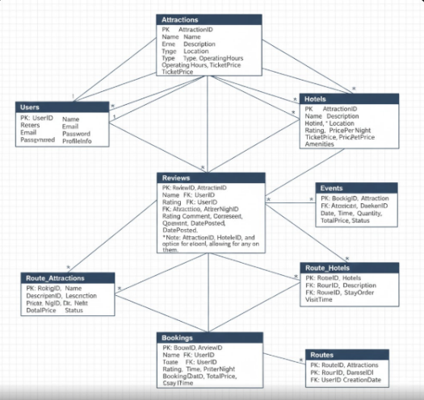

An Entity Relationship Diagram (ERD) is used to illustrate table relationships such as one-to-many links between Users → Bookings and Attractions → Reviews.

3.7 Tools and Technologies
The project used the following tools and technologies:
- Frontend: HTML5, CSS3, JavaScript
- Backend: PHP or Node.js
- Database: MySQL
- Maps: Google Maps API (or Leaflet.js for open-source maps)
- Design Tools: Figma / Adobe XD for UI mock-ups
- Version Control: Git and GitHub

3.8 System Development Environment
Development was carried out on a Windows environment using:
- XAMPP/WAMP for local server setup
- Visual Studio Code as the main code editor
- Browser developer tools for debugging and responsiveness testing

CHAPTER FOUR: SOLUTION ANALYSIS & SPECIFICATION

4.1 Introduction
This chapter presents the analysis and specification of the Travel & Tourism Portal. It documents the requirements identified, models the proposed solution using diagrams and artefacts, specifies the tools used for development, and demonstrates originality and relevance of the solution to the Kenyan tourism context.

4.2 Requirements Determination
Requirements were gathered through document review, online observation, and informal interviews with travellers, tour operators, and hotel managers.

4.2.1 Functional Requirements
The system must:
- Allow users to view tourist attractions, hotels, restaurants, and events
- Enable search and filtering by location, category, budget, and rating
- Support booking and simulated payment
- Allow users to create and manage accounts
- Enable reviews and ratings
- Integrate interactive maps for navigation and planning
- Store and retrieve data securely from a database

4.2.2 Non-Functional Requirements
The system should:
- Be user-friendly, intuitive, and responsive
- Load pages quickly and perform efficiently
- Ensure secure authentication and simulated payment
- Be scalable to accommodate more users and data
- Maintain reliability with consistent uptime and error handling

4.3 Requirements Analysis

4.3.1 Data Flow Diagrams (DFDs)
The system was modelled using DFDs to illustrate data movement and interactions between users and system modules
4.3.2 Use Case Diagrams
Use case diagrams were developed to represent the interactions between actors (travellers, admin, and service providers) and system functionalities.

They include:
- Search and filter attractions, hotels, and events
- Book accommodation and events
- Make payments (simulated)
- Create and manage user accounts
- Post and view reviews
- Access map-based navigation

4.3.3 Solution Modelling Artefacts
Other modelling artefacts include:
- Entity-Relationship Diagram (ERD): Shows relationships between Users, Bookings, Attractions, Hotels, Restaurants, Events, Reviews, and Routes.
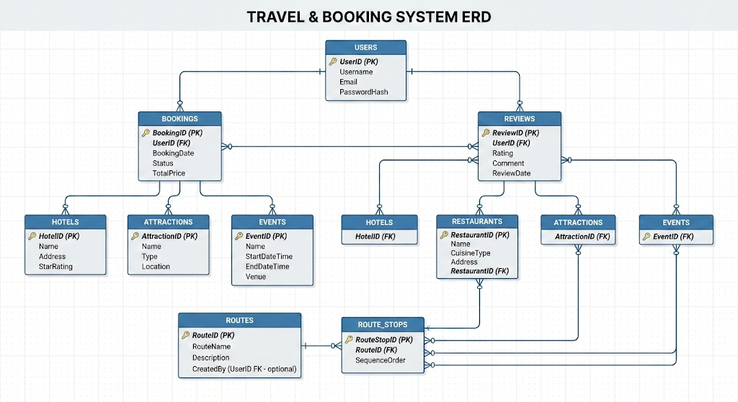

4.4 Solution Specifications
The Travel & Tourism Portal is specified as a web-based platform integrating multiple modules to address the gaps identified in Chapter 2. Key specifications include:
- User Interface: Responsive design using HTML, CSS, and JavaScript for accessibility across desktop and mobile devices
- Backend: PHP/Node.js to implement logic for user accounts, booking, search, and reviews
- Database: MySQL to store and manage structured data
- Maps Integration: Google Maps API or Leaflet.js for route planning and location services
- Booking & Payment Module: Simulated payment integration for demonstration purposes
- Security Measures: Authentication, input validation, and secure data storage

4.5 Requirements Specifications (Tools & Justification)

Tool/Technology | Purpose | Justification
HTML5, CSS3, JavaScript | Frontend development | Ensures responsive, interactive, and user-friendly interface
PHP/Node.js | Backend logic | Supports dynamic content, booking, and user management
MySQL | Database | Efficient storage and retrieval of structured tourism data
Google Maps API / Leaflet.js | Map and route services | Provides interactive maps and geolocation features
Figma / Adobe XD | UI/UX design | Helps create mock-ups and prototypes for usability testing
Git/GitHub | Version control | Tracks development progress and ensures code management

4.6 Student’s Presentation (Originality, Ownership, and Relevance)
The Travel & Tourism Portal is an original solution developed by the student to address the lack of a centralized, user-friendly, and interactive platform for Kenyan tourism.
- Originality: Combines attractions, accommodations, transport routes, events, reviews, and booking features in one system.
- Ownership: Entire system design, development, and documentation were undertaken by the student.
- Relevance: Provides a practical tool to improve travel planning, promote local tourism, and support businesses in Kenya.

4.7 BUDGET SUMMARY
The table below presents an estimated budget for the development of the Travel & Tourism Portal project. The costs are based on typical student project requirements and locally available resources. All amounts are in Kenya Shillings (KES).
Item / Activity | Description | Estimated Cost (KES)
Data Collection | Internet access, document review, online research | 2,000
System Design | UI/UX mock-ups, ERD, DFDs, use case diagrams | 3,000
Software Tools | Code editor, design tools (mostly open-source) | 1,500
Development | Frontend & backend coding, database setup | 5,000
Testing & Debugging | System testing, error fixing | 2,000
Hosting (Local/Test) | Local server setup / test hosting | 1,500
Equipment | Laptop usage, peripherals, power backup, accessories | 8,000
Documentation & Printing | Proposal printing, binding | 3,000
Contingency | Unforeseen expenses | 2,000
Total Estimated Cost |  | 28,000

